Chapter 7: Multiple Regression II

7.1 Extra sums of squares

Measurement of the reduction of the sums of squares when an predictor variable is added to the model given a set of predictor variables are already in the model.

Review SSTO, SSE, and SSR
- SSTO = total sum of squares
- SSE = sum of squared errors (remaining variability of Y not explained by the X₁,…,X_{p-1})
- SSR = regression sum squares (variability of Y accounted for by the X₁,…,X_{p-1})

SSE can be calculated for different sets of variables
- SSE(X₁) = Sum of squared errors using only X₁ in the model (Y_{i}=β₀+β₁X_{1i}+ε_{i})
- SSE(X₁,X₂) = Sum of squared errors using only X₁ and X₂ in the model (Y_{i}=β₀+β₁X_{1i}+β₂X_{2i}+ε_{i})
- SSE(X₁,X₃) = Sum of squared errors using only X₁ and X₃ in the model (Y_{i}=β₀+β₁X_{1i}+β₃X_{3i}+ε_{i})


Remember that as more variables are added to the model the corresponding SSE stays the same or is reduced. For example, SSE(X₁) ≥ SSE(X₁,X₂)

SSR can be partitioned

SSR(X₁) = regression sum squares with only X₁ in the model

SSR(X₂|X₁) = reduction in sum squared errors when X₂ is added to the model given that X₁ is already in the model

SSR(X₂|X₁) = SSE(X₁) - SSE(X₁,X₂)

This is the “extra sum of squares” explained by using the regression model with addition of X₂

SSR(X₃|X₁,X₂) = reduction in regression sum squares due to when X₃ is added to the model given that X₁ and X₂ are already in the model

SSR(X₃|X₁,X₂) = SSE(X₁,X₂) - SSE(X₁,X₂,X₃)

This is the “extra sum of squares” explained by using the regression model with addition of X₃

Suppose there are only three variables under consideration – X₁, X₂, and X₃. Then the “usual” SSR is:

SSR = SSR(X₁) + SSR(X₂|X₁) + SSR(X₃|X₁,X₂)

ANOVA table containing decomposition of SSR:

Source of  variation | df | SS | MS
Regression | 3 | SSR | MSR
X₁ | 1 | SSR(X₁) | MSR(X₁)
X₂|X₁ | 1 | SSR(X₂|X₁) | MSR(X₂|X₁)
X₃|X₁,X₂ | 1 | SSR(X₃|X₁,X₂) | MSR(X₃|X₁,X₂)
Error | n-4 | SSE | MSE
Total | n-1 | SSTO

where MSR = SSR/df

This is what the anova() function in R gives.

There are many other extra sums of squares that could be examined. For example, SSR(X₃,X₂|X₁) = SSE(X₁) - SSE(X₁,X₂,X₃).

7.2 Uses of extra sums of squares in tests for regression coefficients

Model A is nested within model B
Model B has all the terms of model A and at least an additional term (Note: A model term is for example, 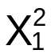)

Reduced Model: Model A
Complete Model: Model B

Example:
Reduced Model: E(Y_{i})=β₀ + β₁X_{i1}
Complete Model: E(Y)=β₀ + β₁X_{i1} + β₂X_{i2}

Example:
Reduced Model: E(Y)=β₀ + β₁X_{i1} + β₂X_{i2}
Complete Model: E(Y)=β₀ + β₁X_{i1} + β₂X_{i2} + β₃X_{i3}
Complete Model: E(Y)=β₀ + β₁X_{i1} + β₂X_{i2} + β₃X_{i3} + β₄X_{i4}

etc…

Hypothesis test steps for a partial (nested) F-test
- H₀: Reduced Model – E(Y)=β₀ + β₁X₁ + ☹ + β_{g}X_{g}
H_{a}: Complete Model – E(Y) = β₀+ β₁X₁ + ☹ + β_{g}X_{g} +
β_{g+1}X_{g+1}+ ☹ + β_{p-1}X_{p-1}

where g < p – 1
Restated another way:
H₀: β_{g+1} = ☹ = β_{p-1}=0 (Note: there are p-1-g β’s =0)
H_{a}: At least one of the β’s in H₀ are
not 0

- Test statistic
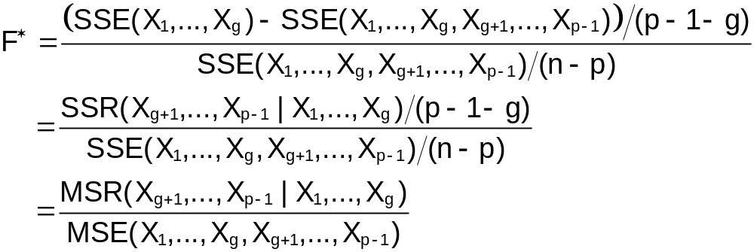
Note:
- SSE(X₁,…,X_{g},X_{g+1},….,X_{p-1}) measures the prediction error in the complete model.
- SSE(X₁,…,X_{g}) measures the prediction error in the reduced model.
- Since SSE(X₁,…,X_{g}) measures the error of a model with less variables than the complete model, SSE(X₁,…,X_{g}) ≥ SSE(X₁,…,X_{g},X_{g+1},….,X_{p-1}).
- SSE(X₁,…,X_{g}) – SSE(X₁,…,X_{g},X_{g+1},….,X_{p-1}) = SSR(X_{g+1},….,X_{p-1}|X₁,…,X_{g}) measures how much the prediction error would be increased by removing the p-1-g variables from the complete model.
- If SSR(X_{g+1},….,X_{p-1}|X₁,…,X_{g}) is small, then F* will be small leading to a “don’t reject H₀” result. This suggests that since the prediction error is not affected much by the removal of variables, the reduced model may be better than the complete model.
- If SSR(X_{g+1},….,X_{p-1}|X₁,…,X_{g}) is large, then F* will be large leading to a “Reject H₀” result. This suggests that the prediction error has increased by a lot when the group of predictor variables are removed. Therefore, use the complete model.

- F(1-α, p-1-g, n-p)

p-1-g = numerator D.F.
n-p = denominator D.F.

- Reject or don’t reject H₀
- Conclusion
- Reject H₀: At least one of the ____ variables are important in predicting Y (complete model is better).
- Don’t reject H₀: There is not sufficient evidence to show that _____ variables are important in predicting Y (reduced model may be better).

Suppose there are only three variables under consideration – X₁, X₂, and X₃. Special cases of the partial F test:

- Test β_{g+1}=0 where g+1=3 for this example
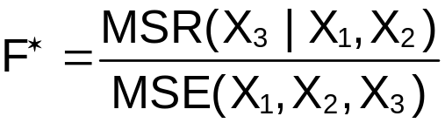 is equivalent to doing a t-test for β₃=0

- Test β₁=β₂=β₃=0
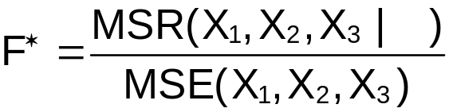 is equivalent to doing a overall F test (Chapter 6)

Example: NBA data (nba_ch7.R)

Determine if FGP (field goal percentage) and FTP (free throw percentage) are important in estimating PPM for the model E(PPM) = β₀ + β₁MPG + β₂Height + β₃FTP + β₄FGP (this is the complete model). Use α=0.05.

> mod.fit.comp<-lm(formula = PPM ~ MPG + height + FTP +
FGP, data = nba)
> mod.fit.red<-lm(formula = PPM ~ MPG + height, data =
nba)
> anova.red<-anova(mod.fit.red)

> #Partial F test
> p<-length(mod.fit.comp$coefficients) #Number of betas
in model is p
> g<-length(mod.fit.red$coefficients)-1 #Number of
variables remaining in the reduced model is g
> F.star<-(anova.red$"Sum Sq"[3] –
anova.comp$"Sum Sq"[5])/(p-1-g) /
anova.comp$"Mean Sq"[5]
> F.star
[1] 7.537712
> alpha<-0.05
> qf(p = 1-alpha, df1 = p-1-g, df2 =
mod.fit.comp$df.residual)
[1] 3.087296

> 1 - pf(q = F.star, df1 = p-1-g, df2 =
mod.fit.comp$df.residual)
[1] 0.0008930397

> #Easier way to do partial F test :)
> anova(mod.fit.red, mod.fit.comp, test = "F") #test =
"F" is default
Analysis of Variance Table

Model 1: PPM ~ MPG + height + FTP + FGP
Model 2: PPM ~ MPG + height
Res.Df RSS Df Sum of Sq F Pr(>F)
1 100 1.00056
2 102 1.15139 2 0.15084 7.5377 0.000893 ***
---
Signif. codes: 0 '***' 0.001 '**' 0.01 '*' 0.05 '.' 0.1 ' ' 1

> #Shows how to get just F statistic out
> anova.compare<-anova(mod.fit.red, mod.fit.comp, test =
"F") #test = "F" is default
> names(anova.compare)
[1] "Res.Df" "RSS" "Df" "Sum of Sq" "F" "Pr(>F)"
> anova.compare$F
[1] NA 7.537712
> anova.compare$F[2]
[1] 7.537712
> anova.compare$Pr(>F) #Does not work
Error: unexpected '>' in " anova.compare$Pr(>"
> anova.compare$"Pr(>F)" #Can always put quotes around
list component
[1] NA 0.0008930397
> anova.compare$"Pr(>F)"[2]
[1] 0.0008930397

- H₀: β₃=β₄=0
H_{a}: At least one of the β’s does not equal to 0

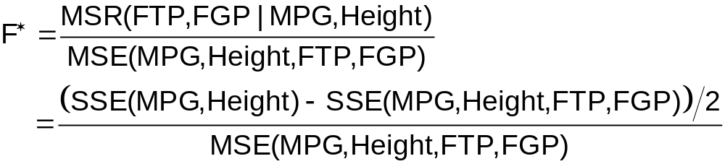
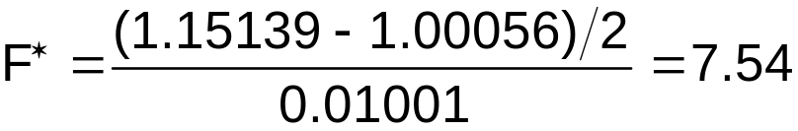

- F(1-α, p-1-g, n-p)=F(0.95, 2, 100) = 3.0873
- Since 7.54 > 3.0873, reject H_{o}
- At least one of the FGP and FTP variables are important in estimating PPM. The complete model is better than the reduced model.

The p-value is 0.000893. Pay special attention to how I was able to extract the F statistic and corresponding p-value out of the anova.compare object.

The anova() function in the stats package can be used a different way than seen so far. For example,

> anova.comp<-anova(object = mod.fit.comp)
> anova.comp

Analysis of Variance Table

Response: PPM
Df Sum Sq Mean Sq F value Pr(>F)
MPG 1 0.18002 0.18002 17.9921 4.96e-05 ***
height 1 0.06530 0.06530 6.5261 0.0121379 *
FTP 1 0.00256 0.00256 0.2556 0.6143010
FGP 1 0.14828 0.14828 14.8199 0.0002087 ***
Residuals 100 1.00056 0.01001

produces

SSR | Value
SSR(X₁) | 0.18002
SSR(X₂|X₁) | 0.06530
SSR(X₃|X₁,X₂) | 0.00256
SSR(X₄|X₁,X₂,X₃) | 0.14828

where X₁=MPG, X₂=Height, X₃=FTP, and X₄=FGP. Note that 0.18002 + 0.06530 + 0.00256 + 0.14828 = 0.39616 = SSR. Notice

> 0.39616/(0.39616+1.00056)
[1] 0.2836359

is R², which can be found as well through the summary() function.

> summary(mod.fit.comp)$r.squared
[1] 0.2836347

Be careful with the hypothesis tests shown in the output. The intent of these hypothesis tests is to be of the form:

Test #1:
H₀: E(PPM) = β₀
H_{a}: E(PPM) = β₀ + β₁MPG

Test #2:
H₀: E(PPM) = β₀ + β₁MPG
H_{a}: E(PPM) = β₀ + β₁MPG + β₂Height

Test #3:
H₀: E(PPM) = β₀ + β₁MPG + β₂Height
H_{a}: E(PPM) = β₀ + β₁MPG + β₂Height + β₃FTP

Test #4:
H₀: E(PPM) = β₀ + β₁MPG + β₂Height + β₃FTP
H_{a}: E(PPM) = β₀ + β₁MPG + β₂Height + β₃FTP +
β₄FGP

BUT, they incorrectly use MSE(MPG, height, FTP, FGP) in the denominator of F∗ for all of the hypothesis tests (the only time this would be correct is for the last hypothesis test). For example, below is some output used to do test #2. Notice the correct p-value for the test given below is different than what was given by the anova() output.

>###################################################
#Test Ho: E(Y) = beta0 + beta1*MPG
# Ha: E(Y) = beta0 + beta1*MPG + beta2*height

> #Initial code
> mod.fit.temp<-lm(formula = PPM ~ MPG + height,
data = nba)
> anova.temp<-anova(mod.fit.temp)
> anova.temp
Analysis of Variance Table

Response: PPM
Df Sum Sq Mean Sq F value Pr(>F)
MPG 1 0.18002 0.18002 15.9477 0.0001230 ***
height 1 0.06530 0.06530 5.7846 0.0179696 *
Residuals 102 1.15139 0.01129
---
Signif. codes: 0 '***' 0.001 '**' 0.01 '*' 0.05 '.' 0.1 ' ' 1

The Anova() function in the car package can be used to produce the usual t-tests give from summary(), but now through partial F-tests.

> summary(mod.fit.comp)$coefficients
Estimate Std. Error t value Pr(>|t|)
(Intercept) -0.8423465759 0.304592589 -2.7654861 0.0067698589
MPG 0.0028959657 0.001121044 2.5832752 0.0112332760
height 0.0041358871 0.001396577 2.9614459 0.0038250550
FTP -0.0001502908 0.001179521 -0.1274168 0.8988663542
FGP 0.0093212453 0.002421318 3.8496580 0.0002086757

> library(car)
> Anova(mod.fit.comp)
Anova Table (Type II tests)

Response: PPM
Sum Sq Df F value Pr(>F)
MPG 0.06677 1 6.6733 0.0112333 *
height 0.08775 1 8.7702 0.0038251 **
FTP 0.00016 1 0.0162 0.8988664
FGP 0.14828 1 14.8199 0.0002087 ***
Residuals 1.00056 100
---
Signif. codes: 0 '***' 0.001 '**' 0.01 '*' 0.05 '.' 0.1 ' ' 1

This function produces what some of you may have heard called “type II” sums of squares. These sums of squares are SSR(MPG | height, FTP, FGP) = 0.06677, …, SSR(FGP | MPG, height, FTP) = 0.14828, where we are examining the contribution of one variable given the other variables are in the model.

7.3 Summary of tests concerning regression coefficients

- Overall F test – Tests the importance of all variables at once. The null hypothesis is H₀:β₁=…=β_{p-1}=0
- T test – Tests the importance of only one variable at a time given the other variables are in the model. The null hypothesis is H₀:β_{g}=0
- Partial F test – Tests the importance of a group of variables at the same time. The null hypothesis is H₀:β_{g+1}=…=β_{p-1}=0 where there are g≤p-1 predictor variables in the reduced model.

The overall F test and the t test are special cases of the partial F test.

7.4 Coefficients of partial determination

Extra sums of squares can be used in calculating a R² given other variables are in the model.

R² - measures the proportion reduction in the variation of Y achieved by using all of the predictor variables in the model.

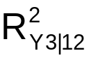 - measures the proportion reduction in SSE by adding X₃ to the model given that X₁ and X₂ are already in the model (this is one specific example).

The “coefficient of partial determination” is calculated the following way for these examples:
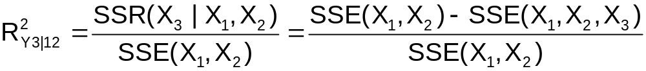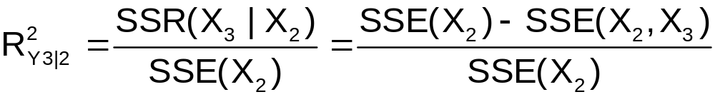
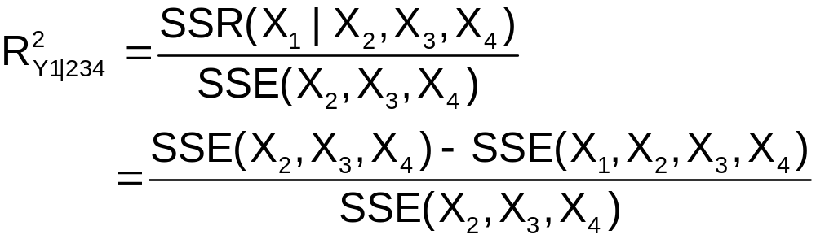

Notes:
- The coefficient of partial determination is between 0 and 1. The closer to 1, the more the reduction in SSE.
- The coefficient of partial determination is often used in “model building” procedures. To determine what predictor variables should be added to a model, the coefficient of partial determination can be examined to see which predictor variable reduces SSE the most.

Example: NBA data (nba_ch7.R)

Determine which predictor variable – Age or FGP – would be the best to add to the model E(PPM) = β₀ + β₁MPG + β₂Height + β₃FTP.

Let X₁=MPG, X₂=Height, X₃=FTP, X₄=FGP, and X₅=Age

> mod.fit.comp1<-lm(formula = PPM ~ MPG + height + FTP +
FGP, data = nba)
> anova.comp1<-anova(mod.fit.comp1)
> mod.fit.comp2<-lm(formula = PPM ~ MPG + height + FTP +
age, data = nba)
> anova.comp2<-anova(mod.fit.comp2)
> mod.fit.red<-lm(formula = PPM ~ MPG + height + FTP,
data = nba)
> anova.red<-anova(mod.fit.red)

> ssr.4.123<-anova.comp1$"Sum Sq"[4]
> ssr.5.123<-anova.comp2$"Sum Sq"[4]
> sse<-anova.red$"Sum Sq"[4]

> anova.comp1$"Sum Sq"[4]/sse #Rsq.4.123
[1] 0.1290706
> anova.comp2$"Sum Sq"[4]/sse #Rsq.5.123
[1] 0.02357182

7.5 Standardized multiple regression model

Read on your own

7.6 Multicollinearity and its effects

When predictor variables are highly correlated with each other, “intercorrelation” or “multicollinearity” is said to exist. This can cause estimates of the β’s to be “unstable” (meaning that from sample-to-sample-to-sample, the b_{j}’s have a lot of variability). Therefore, interpretation of how a predictor and response variable are related by examining the b_{j} may not give good results.

Example: multicollinearity.R

Data is simulated so that the predictor variables X₁ and X₂ are highly correlated. Regression models including X₁, X₂, and X₁ and X₂ as predictor variables are fit to the data.

> #Simulate observations
> set.seed(8171) #set.seed(7110)
> X1<-seq(from = 1, to = 50, by = 1)
> X2<-X1 + 0.1*rnorm(n = 50, mean = 0, sd = 1)
> epsilon<-rnorm(n = 50, mean = 0, sd = 100)
> Y<-2 + 3*X1 + 4*X2 + epsilon

> set1<-data.frame(Y, X1, X2)
> cor(x = set1, method = "pearson")
Y X1 X2
Y 1.000000 0.666022 0.665084
X1 0.666022 1.000000 0.999980
X2 0.665084 0.999980 1.000000

> library(car)
> scatterplotMatrix(x = ~Y+X1+X2, data=set1,
reg.line=lm, smooth=TRUE, span=0.5,
diagonal = 'histogram')
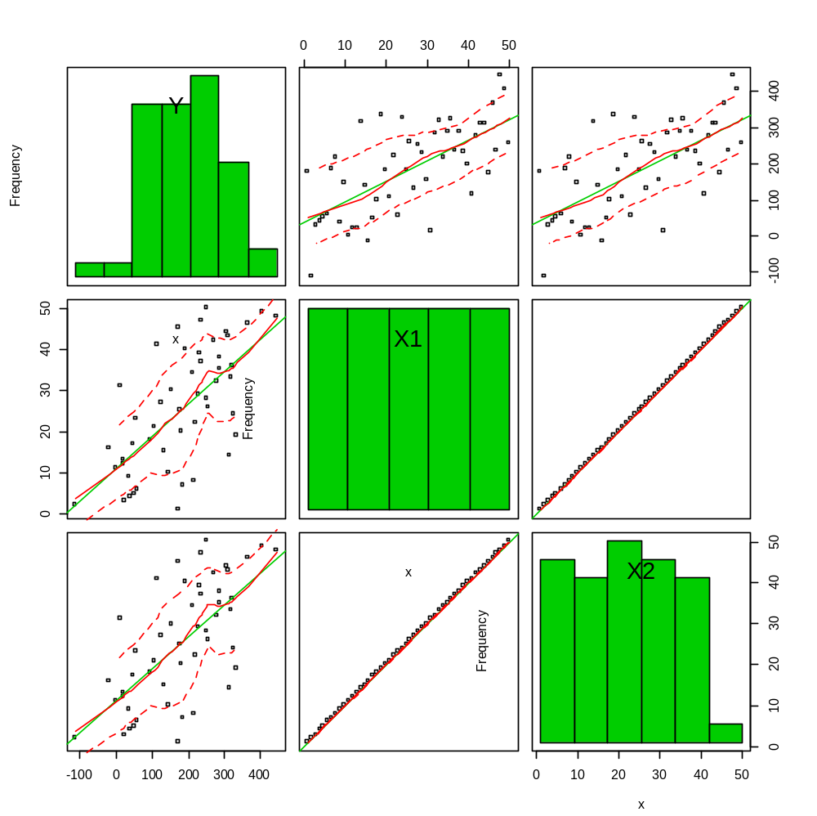

> mod.fit1<-lm(formula = Y ~ X1, data = set1)
> summary(mod.fit1)$coefficients
Estimate Std. Error t value Pr(>|t|)
(Intercept) 38.622047 26.8541153 1.438217 1.568609e-01
X1 5.669576 0.9165174 6.186000 1.302648e-07

> mod.fit2<-lm(formula = Y ~ X2, data = set1)
> summary(mod.fit2)$coefficients
Estimate Std. Error t value Pr(>|t|)
(Intercept) 38.639980 26.9104267 1.435874 1.575235e-01
X2 5.666602 0.9183573 6.170367 1.376431e-07

> mod.fit12<-lm(formula = Y ~ X1 + X2, data = set1)
> summary(mod.fit12)$coefficients
Estimate Std. Error t value Pr(>|t|)
(Intercept) 45.19421 27.03793 1.671511 0.1012668
X1 202.97928 143.78277 1.411708 0.1646224
X2 -197.48828 143.91003 -1.372304 0.1764830

Notes:
- The estimated correlation between X₁ and X₂ is 0.99998.
- The sample regression models are: 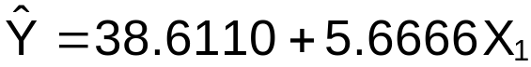, 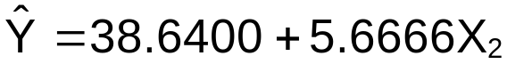, and
- Notice the change in the estimated b_{j}’s between the models. Also, notice the large estimated standard errors.
- I simulated another sample from the population (see the second seed in the program) to illustrate the effect that multicollinearity has on the b_{j}’s. The sample regression models are 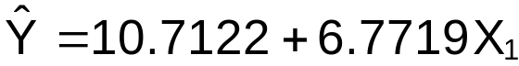, 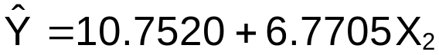, and . Notice the differences between the b_{j}’s for the last model here and the last model in 2).

When multicollinearity does not exist, the b_{j} values should not greatly change when variables are added or removed from the model.

Example: NBA data (nba_ch7.R)

> #columns 1:3 are the name of the player and the number
of games played
> round(cor(x = nba[,-(1:3)], method = "pearson"),2)
PPM MPG height FTP FGP age
PPM 1.00 0.36 0.21 0.17 0.41 -0.05
MPG 0.36 1.00 -0.01 0.39 0.34 0.18
height 0.21 -0.01 1.00 -0.06 -0.11 0.07
FTP 0.17 0.39 -0.06 1.00 0.28 0.25
FGP 0.41 0.34 -0.11 0.28 1.00 0.11
age -0.05 0.18 0.07 0.25 0.11 1.00

Notice that the strongest estimated correlation between the predictor variables is 0.39 and the smallest is
–0.11.

To investigate the changes in the b_{j}’s, variables are added to the model one at a time. Notice that the b_{j}’s do not change too much.

> #Investigate what happens to the b's when one variable is
added at a time
> mod.fit1<-lm(formula = PPM ~ MPG , data = nba)
> summary(mod.fit1)$coefficients
Estimate Std. Error t value Pr(>|t|)
(Intercept) 0.320975692 0.028335757 11.327585 8.392124e-20
MPG 0.004220659 0.001081162 3.903818 1.692911e-04

> mod.fit2<-lm(formula = PPM ~ MPG + height , data = nba)
> summary(mod.fit2)$coefficients
Estimate Std. Error t value Pr(>|t|)
(Intercept) -0.353279837 0.281707620 -1.254066 0.2126845927
MPG 0.004247151 0.001056950 4.018307 0.0001123449
height 0.003542129 0.001472749 2.405114 0.0179696183

> mod.fit3<-lm(formula = PPM ~ MPG + height + FTP, data = nba)
> summary(mod.fit3)$coefficients
Estimate Std. Error t value Pr(>|t|)
(Intercept) -0.4021933208 0.301014824 -1.3361246 0.1845111648
MPG 0.0040331041 0.001153043 3.4977918 0.0006989877
height 0.0035858278 0.001481248 2.4208156 0.0172708941
FTP 0.0005883381 0.001240881 0.4741292 0.6364311575
> mod.fit4<-lm(formula = PPM ~ MPG + height + FTP + FGP, data
= nba)
> summary(mod.fit4)$coefficients
Estimate Std. Error t value Pr(>|t|)
(Intercept) -0.8423465759 0.304592589 -2.7654861 0.0067698589
MPG 0.0028959657 0.001121044 2.5832752 0.0112332760
height 0.0041358871 0.001396577 2.9614459 0.0038250550
FTP -0.0001502908 0.001179521 -0.1274168 0.8988663542
FGP 0.0093212453 0.002421318 3.8496580 0.0002086757

> mod.fit5<-lm(formula = PPM ~ MPG + height + FTP + FGP + age,
data = nba)
> summary(mod.fit5)$coefficients
Estimate Std. Error t value Pr(>|t|)
(Intercept) -0.7789793864 0.303498602 -2.5666655 0.0117653419
MPG 0.0030577913 0.001112990 2.7473662 0.0071388463
height 0.0043557998 0.001387429 3.1394748 0.0022310525
FTP 0.0002588242 0.001189714 0.2175517 0.8282262122
FGP 0.0094399054 0.002396752 3.9386243 0.0001526399
age -0.0053145895 0.002999118 -1.7720505 0.0794626630

Notes:
- A simple solution to multicollinearity problems is to just use one of the predictor variables because they are measuring similar things.
- In Section 10.5, other methods are introduced to detect multicollinearity.
- In Section 11.2, remedial measures are introduced to lessen the effect of multicollinearity.
- Multicollinearity generally does not affect predicting Y or the C.I.s for E(Y) and P.I.s for Y.

